**Pseudocode**

Pseudocode is half English and half code.

It has no real syntax and would not run as program code.

It does use program constructs.

It is useful for planning algorithms without knowing the exact syntax of the value.

**5 major protocols in python pseudocode**

1) The pseudocode in python must be line by line.

2) Just as in python code how indentations are used, these indentations must be preferred in python pseudocode.

3) Ensure each statement is simple and easy.

4) Ensure the first word in the pseudocode is in upper case letters.

5) Ensure to use periods and delimiters wherever needed.

**Suggested language for pseudocode**

* Use indentation in pseudocode
* Use words such as:

Input, output, display output

Calculate, add, set

If then, else, endif

**Pseudocode example**

If unlock button pressed then

Display pin unlock screen

Input pin

If correct pin entered, then

unlock phone

Else display “Try again”

Endif

Else display lock screen

endif

**#Password checker**

If the user enters the password abcd1234 it will print access granted. If they enter anything else, it will print access denied and say press enter to exit.

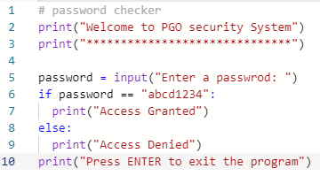

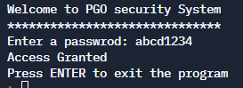

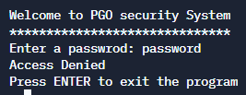

**Pseudocode**

OUTPUT (“Welcome to PGO security system”)

OUTPUT (“************************”)

Password = INPUT (“ENTER A PASSWORD”)

IF password == “abcd1234” THEN

OUTPUT (“Access Granted”)

ELSE

OUTPUT (“Access Denied”)

ENDIF

OUTPUT (“Press ENTER to exit the program”)